Module: Purchasing
Topic: PO Inquiry & Reports
Purchase Order Inquiry & Reports MUNIS Version 19.1

Objective
This document provides step-by-step instruction on how to inquire and report on existing EERP/Munis purchase orders.

Purchase Order Inquiry

- Open Purchase Order Inquiry
Departmental Functions>Purchase Order Inquiry

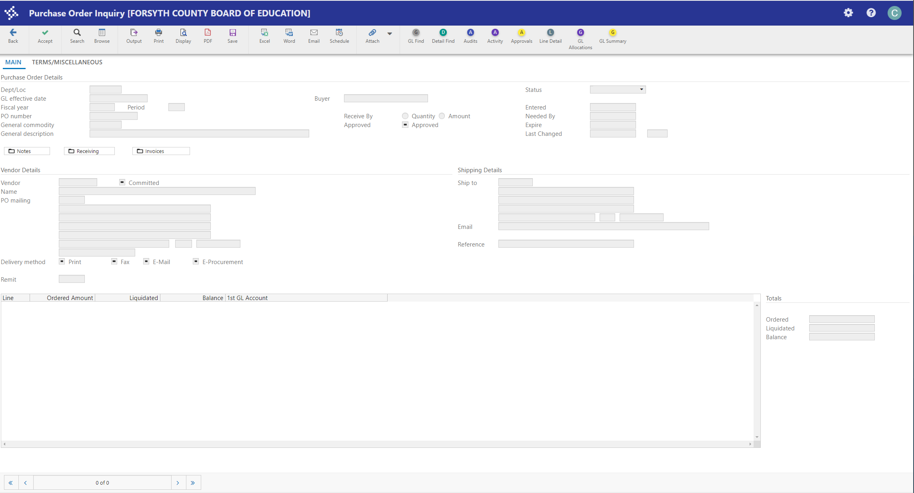

- Find a record or multiple records
Click the Search icon 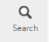 (or CTRL + F). Once you click the Search icon, you can do a search on one or more of the available fields on the Purchase Order Find screen.

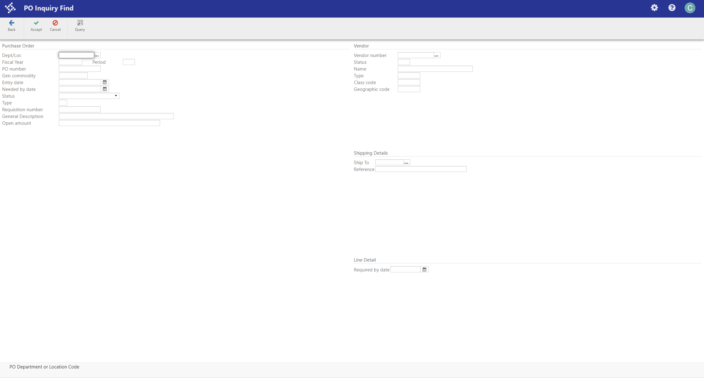

Field | Description
Dept/Loc | Enter the Dept/Loc code of the purchasing department.
Fiscal Year | Enter the fiscal year in which the purchase order was created.
PO Number | System generated number assigned to the purchase order.
Status | 0 = Closed  2 = Creation (header created but GL detail not completed)  4 = Allocated (GL allocation completed)  6 = Posted  8 = Printed
Requisition Number | The system generated number of the requisition that was converted into the purchase order.
Vendor | The vendor number as set up in the Accounts Payable and Purchasing modules.
Name | The name of the vendor

Once the search criteria have been entered, click the Accept icon 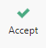 on the toolbar to display the search results. For this example, we did a search for any purchase orders for school 12 in fiscal year 2023

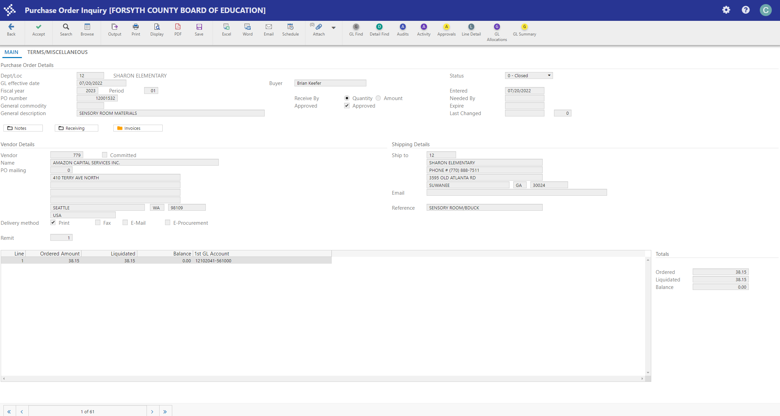

The first PO in the output selection is displayed. Note that the total number of POs in the selection is displayed on the bottom of the screen. POs can be scrolled through using the arrows.

Status:

Printed = either the PO has not been paid or it has open amounts, such as back orders. Open items will appear in the balance column.

Closed = the purchase order has been paid in full or the purchase order has been voided.

If invoices have been processed for a purchase order you will see amounts in the liquidated column. If we made a partial payment on a purchase order you will see amounts in the balance column.

The liquidated amounts are not always the same amount that was paid on an invoice.

To see what was actually paid on an invoice click on the “invoice tab” 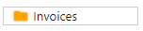
It will bring up the following screen:

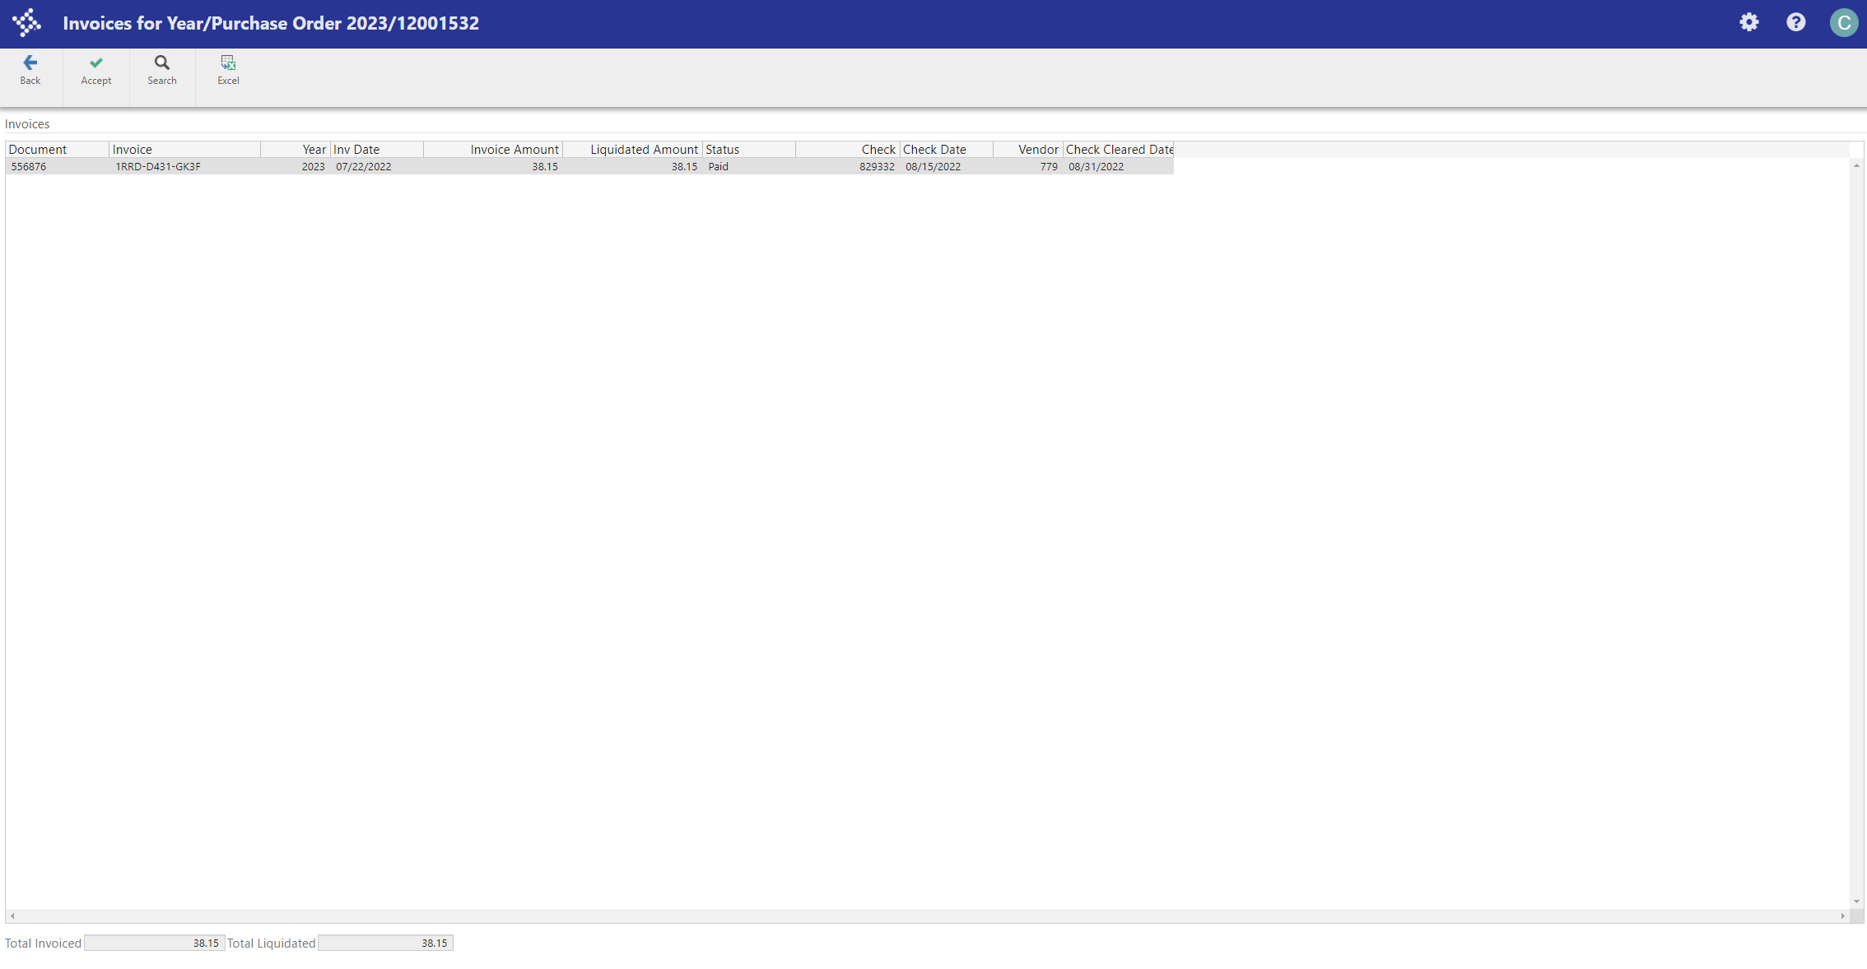

This screen will show the following:
- Invoice #
- Invoice date
- Invoice amount
- Check #
- Check date

At the bottom of the screen you will see the totals of all processed invoices.

Click Back 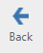 take you back to the previous screen.
Output
Once you have found some records, you may want to output them. There are several output types for Purchase Orders including Browse, Display, Print, PDF, Excel, Word and File Output. You can output lists of all purchase orders or details pertaining to specific purchase orders.

Browse - By selecting the Browse icon 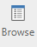 from the toolbar all the records in the active set are displayed in a list format.

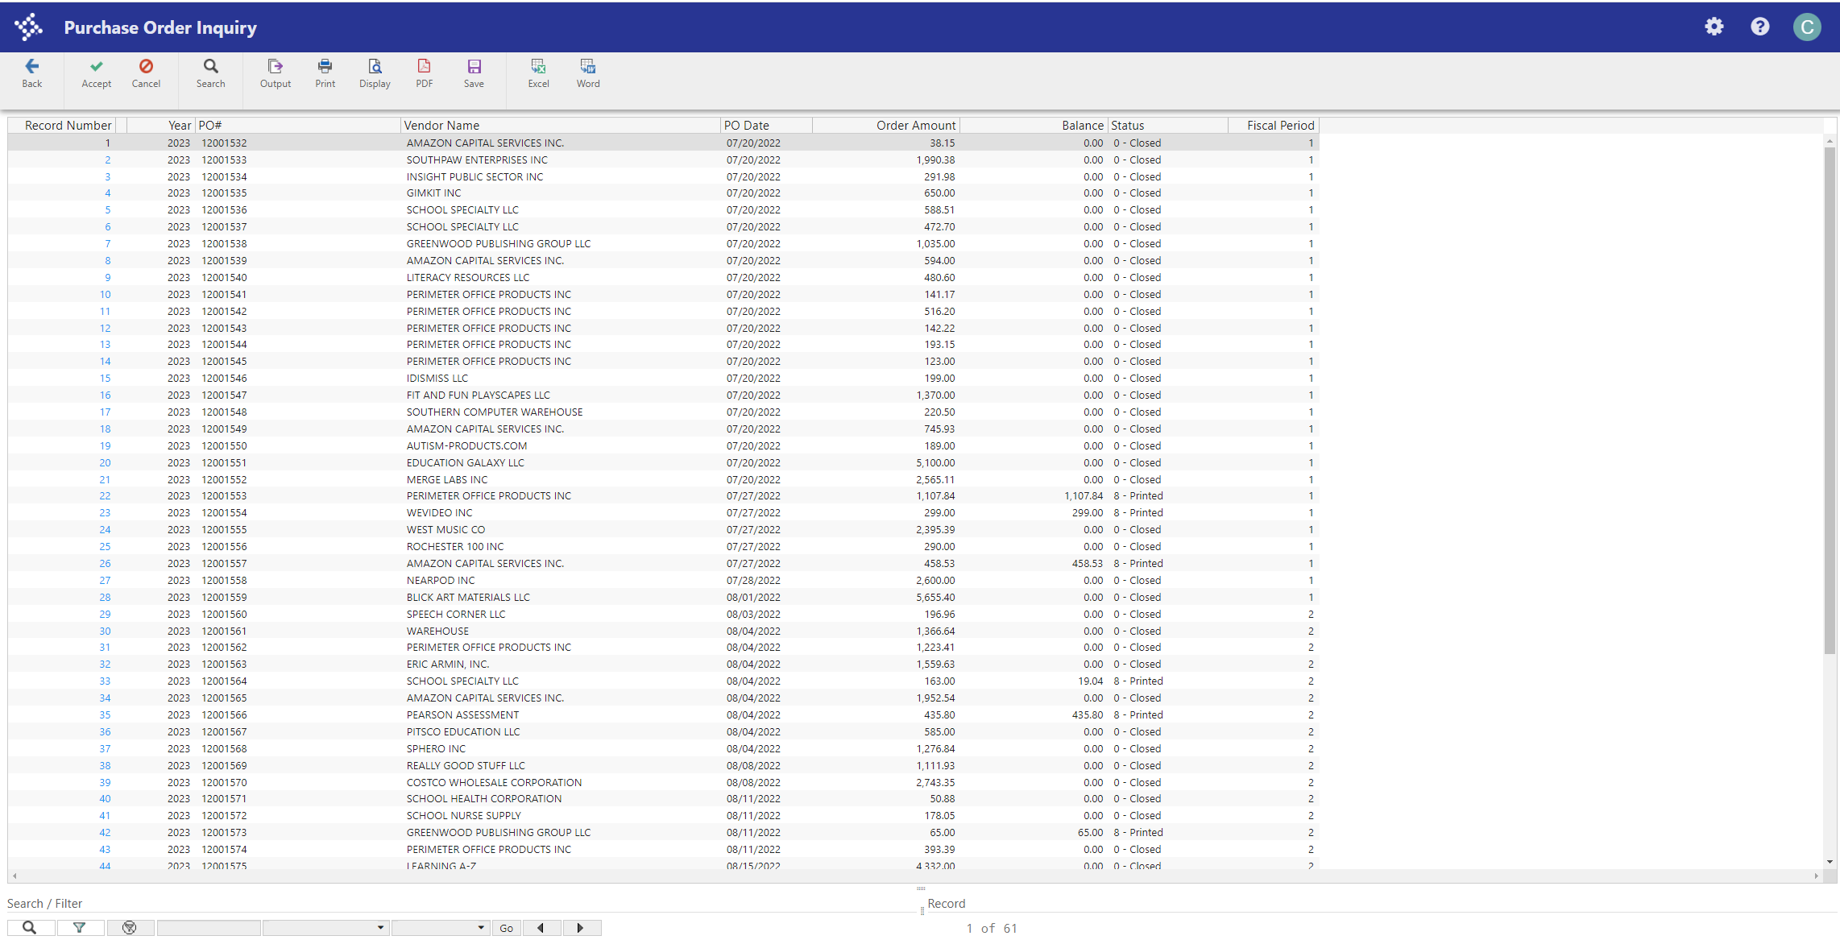

Sort any of the columns by simply clicking on the column heading.

To add or remove columns from the display screen, right click in any of the column headings. Select the columns you wish to view, or clear those you wish to hide by clicking on the column title. The display will be reformatted according to your selections. When you create an output file or report from a browse screen, the output does not include columns that you have hidden on the screen display.

Select a record by double clicking on the record.
Export to Excel - From the browse window, click the Excel icon on the toolbar to create an Excel spreadsheet of the active set of data. Only the columns that are displayed in the browse window will be exported.

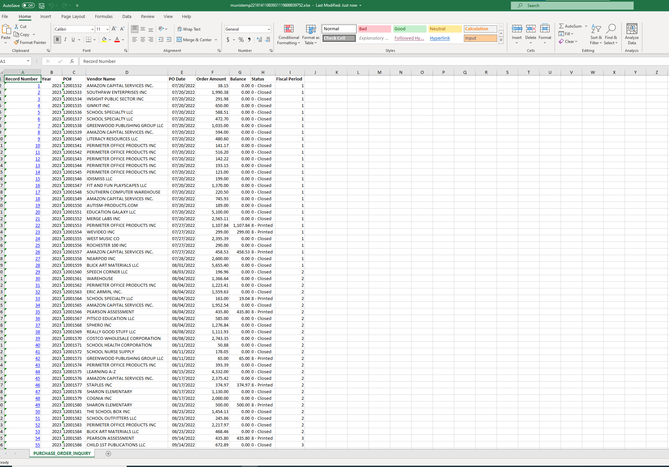

You can manipulate the data within Excel as you would with any other spreadsheet. Save the Excel file with a new name.

Display – allows you to view a report on the screen of the found records.
Click the Display icon on the toolbar (or File > Display). The following box appears:
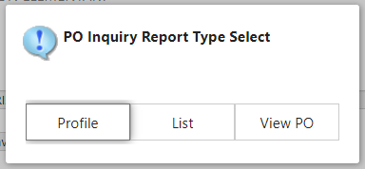

Select an Option (Profile, List or View PO).
- If Profile is selected, a profile report for the current record that is displayed within Purchase Order Inquiry will now be displayed within the formatted Display Page. You may also display this report in PDF format.
- If List is selected, the PO List Report for all records in the active set will now be displayed within the formatted Display Page. You may also display this report in PDF format.
- If View PO is selected, the purchase order for the current record that is displayed within Purchase Order Inquiry will be displayed within the formatted Display Page. You may also display this report in PDF format.

Print – the Print Icon 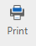 on the toolbar will send a report directly to your default MUNIS printer. . To choose a specific printer or print multiple copies you must use the File > Output option from the menu.

Click the Printer Icon on the toolbar.
Choose the desired printing format (Profile, List or View PO) and click Accept .
- If Profile is selected, a profile report for the current record that is displayed within Purchase Order Inquiry will now be displayed within the MUNIS Display Page. You may also display this report in PDF format.
- If List is selected, the PO List Report for all records in the active set will now be displayed within the MUNIS Display Page. You may also display this report in PDF format.
- If View PO is selected, the purchase order for the current record that is displayed within Purchase Order Inquiry will be displayed within the MUNIS Display Page. You may also display this report in PDF format.

Your report will print to your default MUNIS printer.

File Output – the File Output option provides you with several options to output a report. These are the same options as defined above and also include an option to select a different printer than your default, print to a local printer, print more than one copy, or you can give your spool file a different name than the default.

